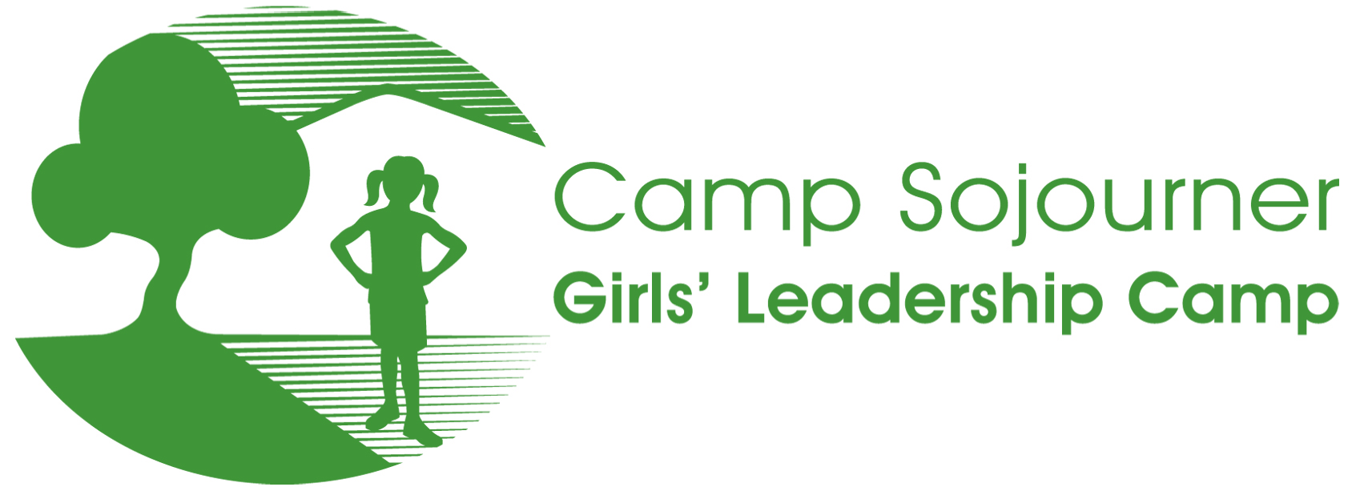
RETURNING CAMPER QUESTIONS

My name is ____________________________ and I am ________ years old.

I want to go back to Camp Sojourner this summer because ___________________________________________________________________

Some things I really liked about camp last summer:

Some suggestions I have for how camp could be improved this summer:

Some things I did really well at camp last summer:

Ways I could improve as a camper this summer:

Two Goals I have for my time at camp this year:
1.

2.

One issue or problem in my community or the world that I would like to do something to help change or improve:

Any other comments or thoughts?

________________________________________________________________________________ _____________

Signature of Camp Sojourner Applicant Date

Thank you for being a part of Camp Sojourner, Girls’ Leadership Camp! We look forward to seeing you this summer!

