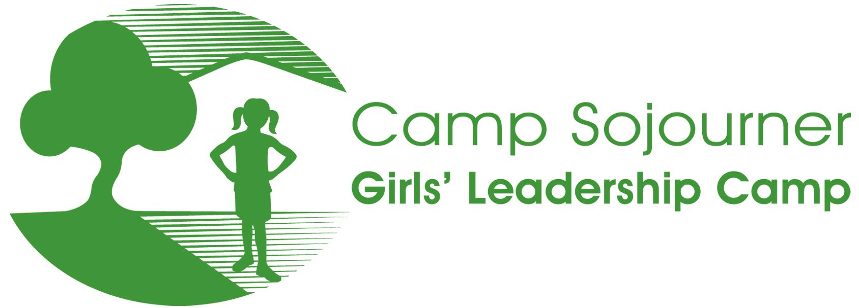

STAFF APPLICATION 2018

Camp Sojourner Overview
Camp Sojourner is an affordable overnight camp for Philadelphia-area girls between the ages of 8 and 17, focused on team-building, leadership development, appreciation of nature, and creative arts. Camp Sojourner’s mission is to provide girls with a rewarding and life-changing sleepaway camp experience, which will ultimately help them become strong leaders who take charge of their own lives and make a positive impact on the larger world around them. Towards this end, we also offer girls year-round mentoring, service projects, and enrichment activities. We are a nonprofit organization, and we fundraise all year so that we can provide these opportunities to girls no matter what their families can afford to pay.

Camp Sojourner takes place on a gorgeous mountain lake at the New Jersey School of Conservation in Stokes State Forest, about two and a half hours from both Philadelphia and New York City. We are expecting to serve 75 campers this summer, including 14-17 year old teen leaders. Our program includes traditional camp activities such as swimming, boating, hiking, team-building, and campfires, as well as creative and performing arts such as singing, dancing, drawing, painting, drumming, sewing, and wood-working.

Camp Sojourner seeks to create a diverse community where the dignity and experience of all participants are honored. All staff must be committed to:

- the positive development of girls;
- working collaboratively with youth and adults;
- building relationships with people different from themselves;
- communicating openly and honestly; and,
- encouraging campers in their exploration of creative arts and the natural environment.

Camp Sojourner strives to provide its campers a staff that is reflective of their cultural and socioeconomic backgrounds—many of our campers are from low-income and working class communities of color. Women from these backgrounds are strongly encouraged to apply. Please note, however, that we welcome qualified candidates from all backgrounds, and affirm the value of a diverse community that represents a broad range of experiences and perspectives.

Volunteer/Job Announcement
Camp Sojourner seeks adult women interested in working with us for one week to help provide girls with a fun yet challenging overnight camp experience. Applications are being accepted for the positions of Cabin Counselor and Program Specialist. Program Specialist positions are related to creative arts: dance, theater, singing, drumming, visual arts, and creative writing. Program Specialists, except in special circumstances, live with campers and serve as cabin counselors during meals and cabin times, with extra time off given for preparation of program area activities.

Our camp program is shaped by the skills and talents of our staff. Successful staff come to camp with a strong ability to both nurture young people and set appropriate limits. Successful program staff come to camp with years of experience working with young people in their specific areas, and are ready to develop and share the activities they offer with genuine enthusiasm.

The summer 2019 camp program will run from Monday, July 29 through Saturday, August 3. Staff training begins on Saturday, July 27 at 12:00 noon. The staff bus will depart Philadelphia at 8:30am on Saturday, July 27. Staff will return to Philadelphia at approximately 9:00pm on Saturday, August 3.

All camp staff serve as volunteers, and are provided with room, board, and a stipend of $250.

To apply for a position with our program, please email a current resume along with a completed application to info@girlsleadershipcamp.org. Applications are accepted on a rolling basis, and qualified applicants will be asked to schedule an in-person interview. Positions will be offered as soon as possible in order to allow applicants to finalize summer plans.

Contact
email:
info@girlsleadershipcamp.org.

mail:
Camp Sojourner, Girls’ Leadership Camp
801 S. 48th St.
Philadelphia, PA 19143

phone:
(215) 951-0330 x2180

If you have any questions, the best way to reach us is via email. The camp voicemail is retrieved about once a week, but calls will be returned as soon as possible. Email is the best way to contact us for a prompt reply.

We hope you choose to join us in making a difference in the lives of Philadelphia girls! We look forward to hearing from you.

2019 Summer Camp Staff Application

Thank you for your interest in working with Camp Sojourner, Girls' Leadership Camp. This application can be completed electronically and then emailed to our camp office at info@girlsleadershipcamp.org. Please put your name in the title of the document.
Full name:
Preferred name/ nickname:
Street Address:
City, State, Zip Code:
Phone:
Email:
Race and/or ethnicity (optional):
Are you from a low-income or working class background? (optional):
Date of Birth (optional):

The following questions can be answered in the spaces provided, and/or on a separate paper. Please be as specific as possible in your responses.

- Why are you interested in being a summer staff member at Camp Sojourner?

- What position(s) are you applying for?

- What age group do you feel most comfortable working with? Why?

- Please briefly describe your leadership experience working with children and youth, including any supervisory experience.

- Besides leadership experience, what other experience have you had working with children and/or youth?

- What experience have you had working at summer camps? Please specify whether your experience is in residential or day camp programs and what positions you held. (Note, this is not a requirement for being considered for a position with Camp Sojourner.)

- What experience have you had working specifically with youth from low-income or working class communities of color?

- What experience have you had working in or being part of a diverse community?

- What do you think a good camping experience can do for a child, and how can you contribute as a leader to that experience?

- Counselors at Camp Sojourner are responsible for leading discussions with their cabin groups, and helping girls in their cabin learn facilitation skills. Please tell us about a time when you facilitated a discussion with young people. How was the conversation structured? What made the discussion successful? Challenging?

- What are some ways that you can help build the leadership skills of the campers in your care? (You may define “leadership skills” according to what is most meaningful to you.)

- Do you have First Aid, CPR, Life Guarding, or Waterfront Certifications? If so, please be specific as to what certifications you hold. If not, would you be willing to get certified (at our expense)?

- What other experiences or abilities do you have to offer to Camp Sojourner?

- Is there anything else you would like us to know about you?

- Have you ever been convicted of a crime, other than a minor traffic offense? ______
If yes, please describe. (Note: a prior conviction is not an automatic bar to employment. The type of conviction and when it occurred will be evaluated by the camp before any decision is made.)

- How did you hear about Camp Sojourner?

List the names and contact information for three people, other than relatives or significant others, who can comment on your abilities in the position for which you are applying. Please indicate the capacity and dates when the people have known you. At least one reference must be a current or recent employer. At least one reference must be able to speak about your experience working with children.
Name:
Company/organization and title:
Relationship to you:
Telephone:
Email (if available):

Name:
Company/organization and title:
Relationship to you:
Telephone:
Email (if available):

Name:
Company/organization and title:
Relationship to you:
Telephone:
Email (if available):

I testify to the truth of this application and authorize investigation of all statements herein, including any checks of criminal records.

Signature ____________________________________________ Date_____________________

Thank you for your interest in working with Camp Sojourner, Girls’ Leadership Camp! We will contact you promptly in order to acknowledge receipt of your application, and to schedule an interview if appropriate.

