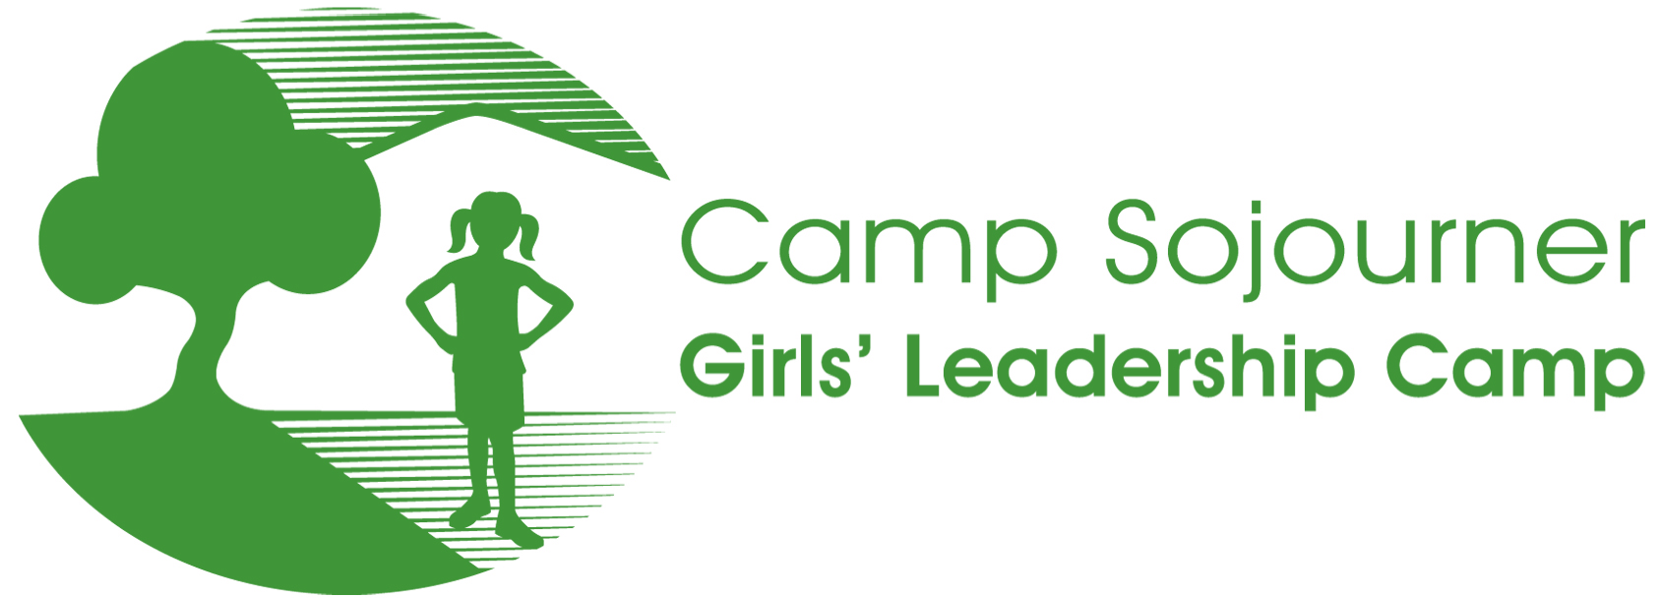

RETURNING CAMPER QUESTIONS

My name is ____________________________ and I am ________ years old. My school is ________________________________.

I want to attend Camp Sojourner this summer because…__________________________________________________________

In the past, some things I really liked about camp are…

I hope this summer at camp this summer we…

This year in general, I have enjoyed…

Some things that have been challenging for me / my family this past year are…

Two things I feel grateful for in the world right now:
1.

2.

Two things I am concerned about in the world right now:
1.

2.

Which of the following creative arts would you be interested in doing at camp? (Circle as many as you like.)

Dance Drumming Theater Creative Writing Singing Painting Drill Team Other _____________________

If we are able to offer instructional swimming at camp this year, would you be interested in participating in that? Yes No

Any other comments or thoughts? Please write on back. Thank you for being a part of Camp Sojourner!

______________________________________________________________________ _____________

Signature of Camp Sojourner Applicant Date

